**System Design Interview Questions**

**Design a Chat application.**

**Gather requirements**

* Clarify the functional requirement questions with interviewer.

Like, it is one to one message chat application, or should it support group chats.

Should it support any document like images, pdf file or just text message.

Online status of users.

Push notification. Etc..

* Clarify the non-functional requirements

Scalability – How many messages do we handle daily ?

Availability – always operational

Latency – API target 10ms

**Estimation**

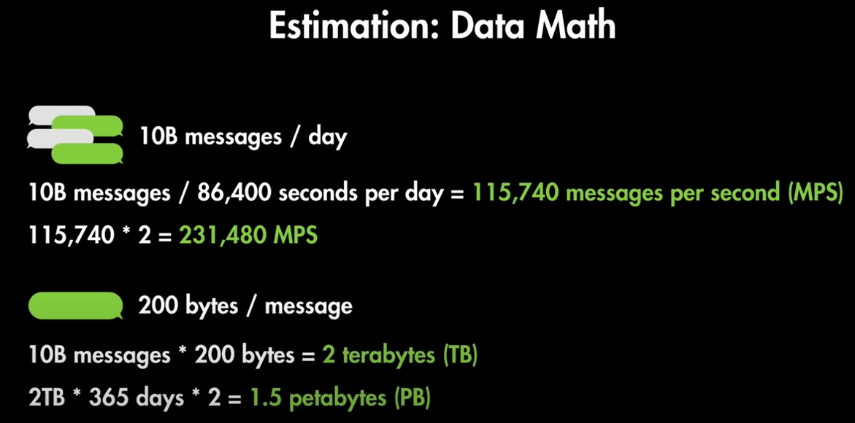

**High Level API design**

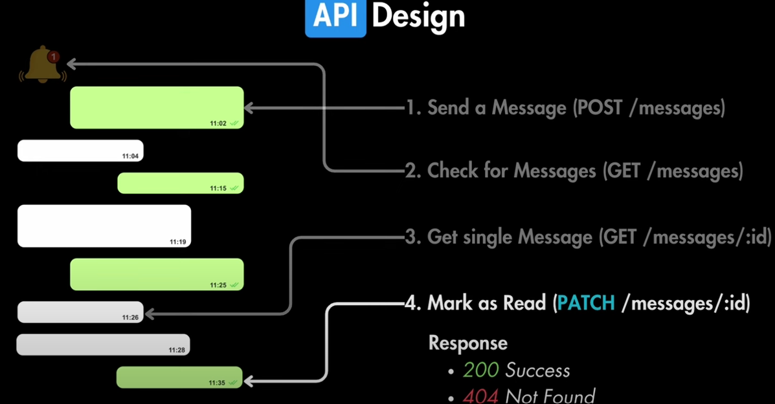

**High Level System Design**

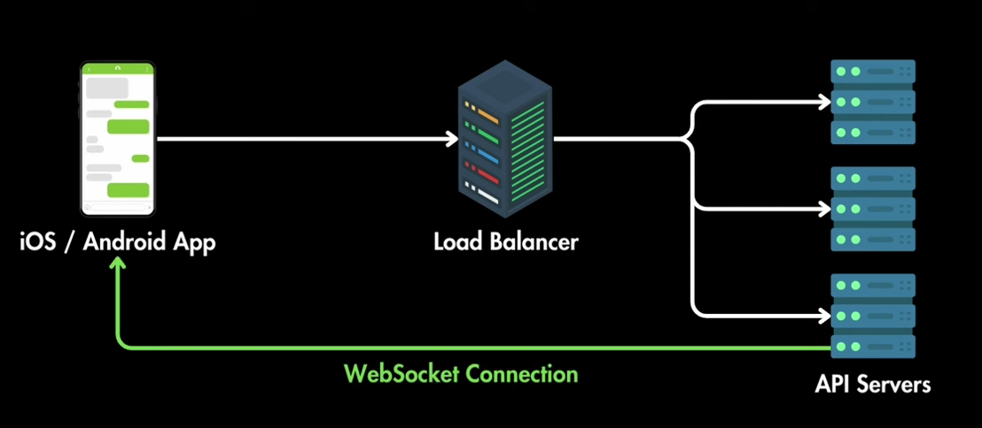

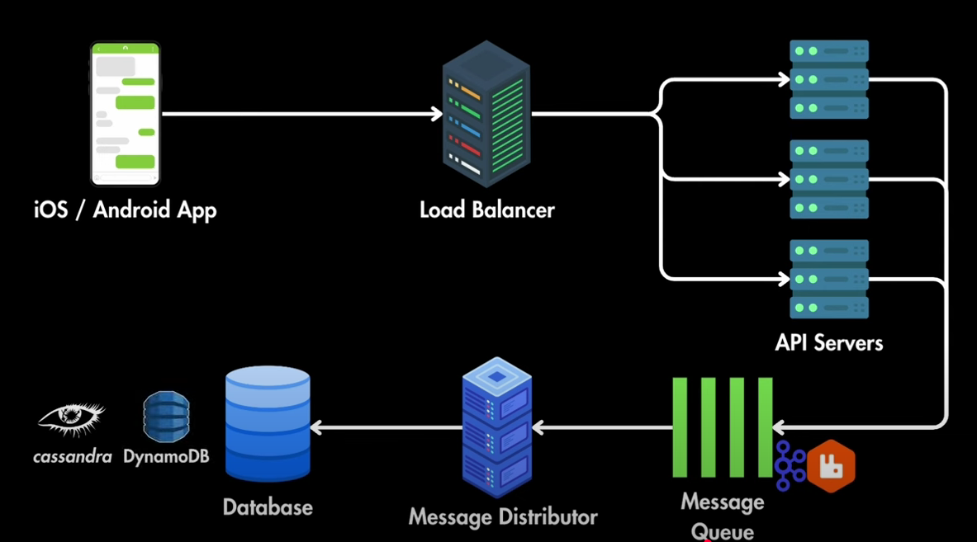

**Implement rate limiter in your application.**

If you are creating the API, it can be used by many clients. Sometimes some of the clients consume the API frequently without any limit. But if you want to limit consuming the API for a particular client within a certain time, then you can achieve it by ***Rate Limiting***.

Rate Limiting is the process of ***controlling the number of requests for a resource within a specific time window***. Each unique user/IP address/client will have a limitation on the number of requests to an API endpoint.

Why do we need Rate Limiting?

* Rate Limiting helps us to protect against malicious bot attacks. For example, a hacker can use bots to make repeated requests to an API endpoint. Due to the number of repeated requests, resulting in will be service unavailable for others. This is called as the ***Denial of Service (DoS)*** attack. So, the rate limiting helps us from the DoS attack.
* Another use of the rate limiting is to regulate traffic to the API.

We can implement the rate limiting using below ways,

* Using a Custom Middleware
* Using the AspNetCoreRateLimit NuGet Package

**Step 1** :

Install the ***AspNetCoreRateLimit***NuGet Package to implement the Rate Limiting in your Web application.

The [***AspNetCoreRateLimit***](https://www.nuget.org/packages/AspNetCoreRateLimit/) NuGet package is used to implement the rate limiting features directly in the ASP.NET Core pipeline. The AspNetCoreRateLimit package contains an ***IpRateLimitMiddleware*** and a ***ClientRateLimitMiddleware***to support the IP Address and client-key limit respectively.

**Step 2 :**

To configure the rate limiting to use in-memory persistence, add the following lines to the ***ConfigureServices()*** method in ***Startup***class.

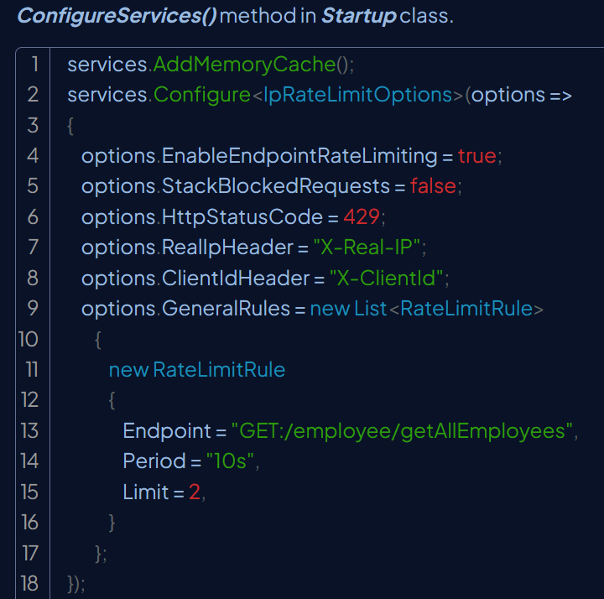

In the above code, the option ***EnableEndpointRateLimiting***is set as true to ensure that limit is applied to specific endpoints (here ***employee/getAllEmployees***) rather than all endpoints. If EnableEndpointRateLimiting is set to false then the limits will apply globally and only rules that have as endpoint* will apply.

The **RealIpHeader** is used to extract the client IP when your Kestrel server is behind a reverse proxy, if your proxy uses a different header, then X-Real-IP uses this option to set it up.

The **ClientIdHeader** is used to extract the client id for whitelisting, if a client id is present in this header and matches a value specified in ClientWhitelist then no rate limits are applied.

The rate limiting rules are set in the GeneralRules section. In the above example, the rule specifies that for the endpoint /employee/getAllEmployees with an HTTP verb GET, allow only 2 requests in a time window of 10 seconds.

**Step 3** :

Add the following lines to the ***Configure()*** method in ***Startup***class.

app.UseIpRateLimiting();

In the above example, the rule specifies that for all endpoints, allow only 2 requests in a time window of 10 seconds. If the request is from the same IP, consider 3 GET calls to ***getAllEmployees***, the last call (3rd call) will get blocked. But if in the same second you call PUT in employee then the request will go through because it's a different endpoint.

**System Design Concepts**

System Design isn’t about writing code, it’s the big picture which is based on the principles of distributed systems

A distributed system is a group of computer working together to achieve a common goal.

Group of computers can handle more data, serve more users and can do tougher tasks than one computer alone

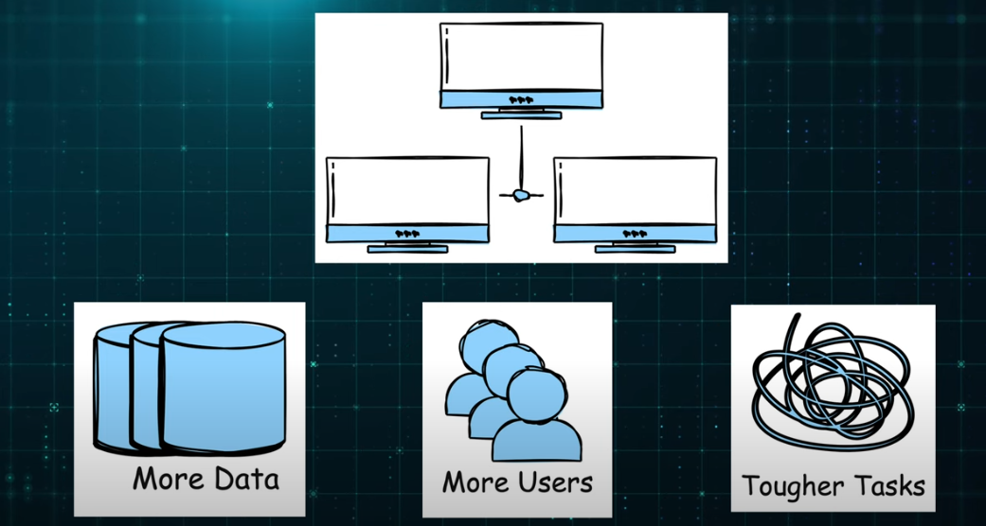

System design involves:

* Figuring out what are the requirements of system
* Who are the Users of system and how many users are respected to use it.
* What components do we need in our system design
* How these components should be organized or connected
* How to make the system scalable
* How to make system reliable
* How to make the system easy to maintain

**Concepts**

1. **Scalability**

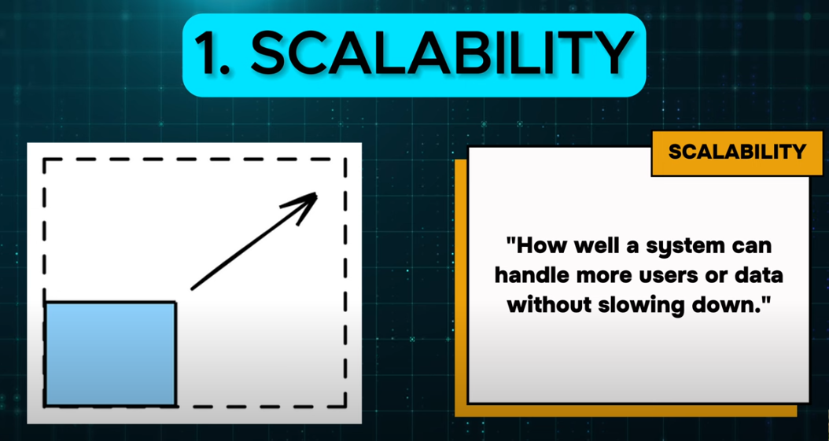

Two types of scaling : Vertical - When you add more resources to a single machine like bigger hard drive or more memory.

Horizontal - When you add more machines to your system to spread the load

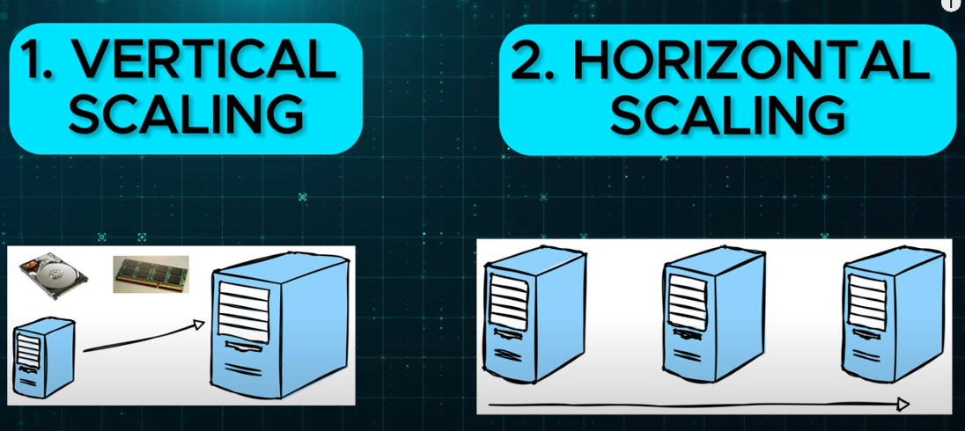

**2.Performance**

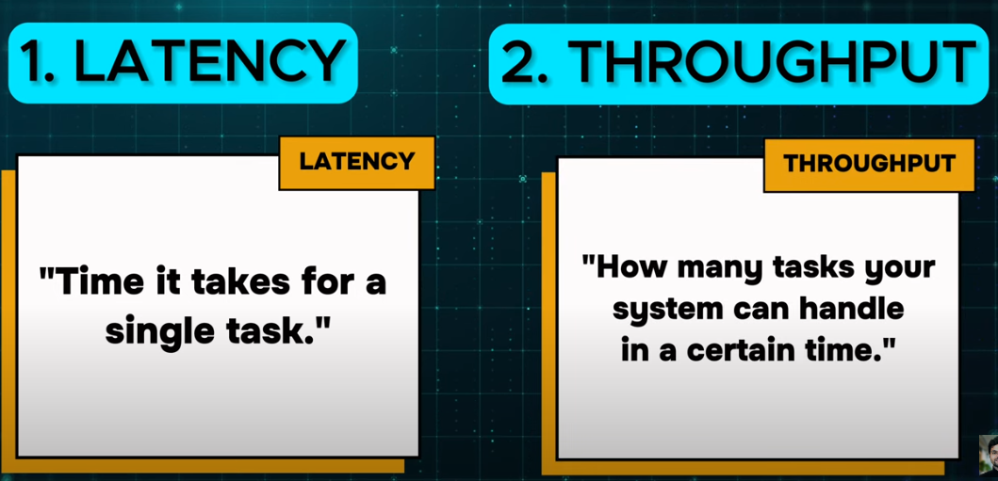

**3.Availablity**

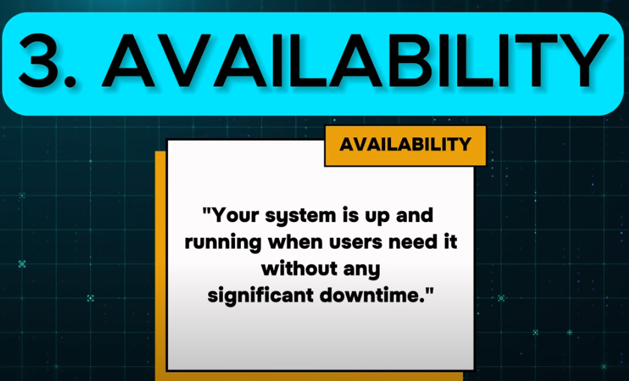

**4. Reliablility**

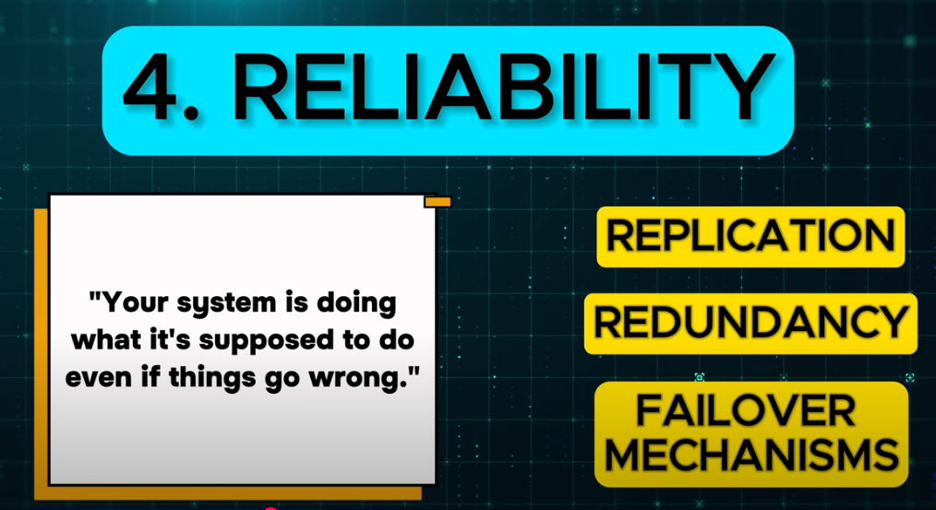

**5. Consistency**

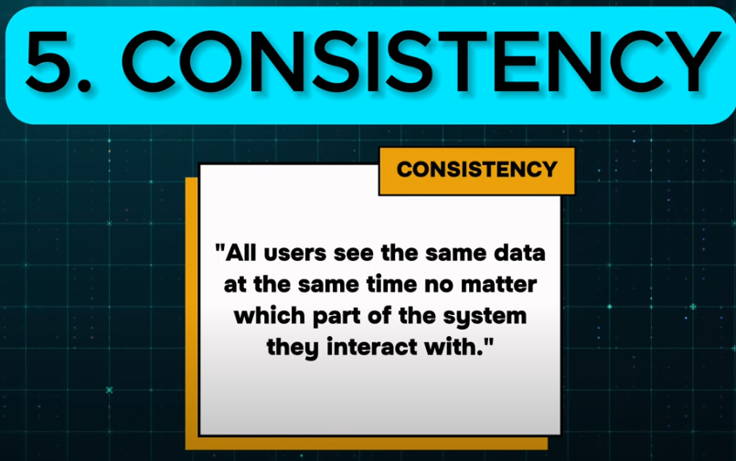

6. CAP Theorem

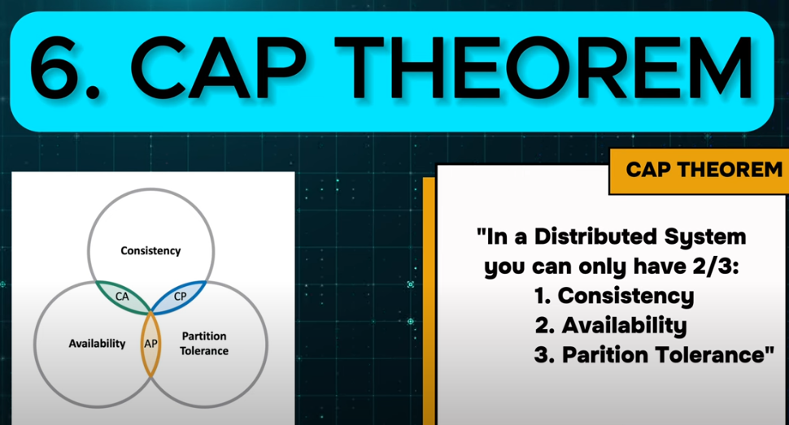

7.Data Storage and retrival

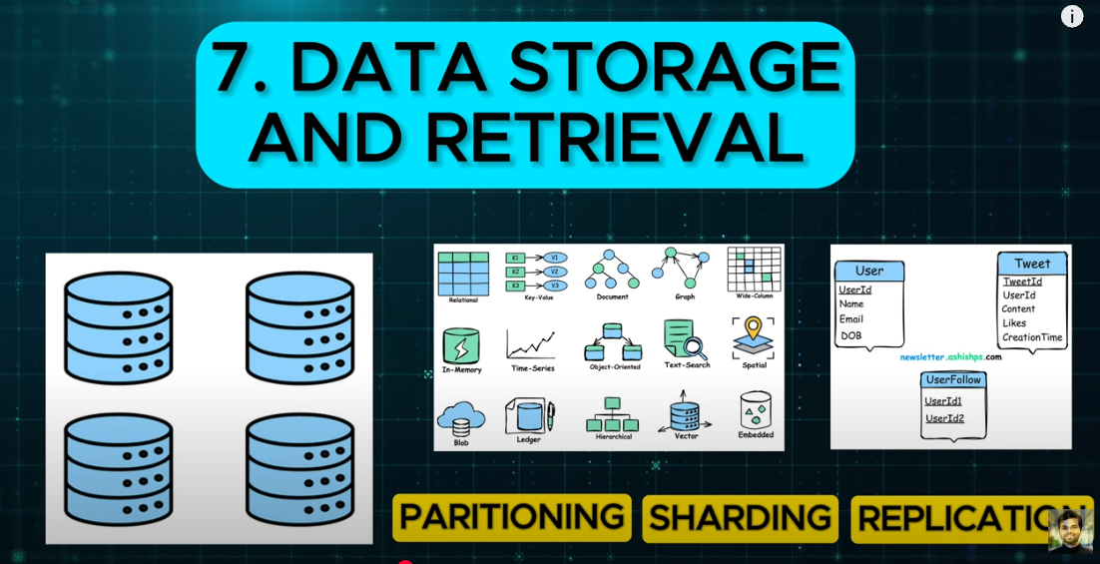

8.ACID

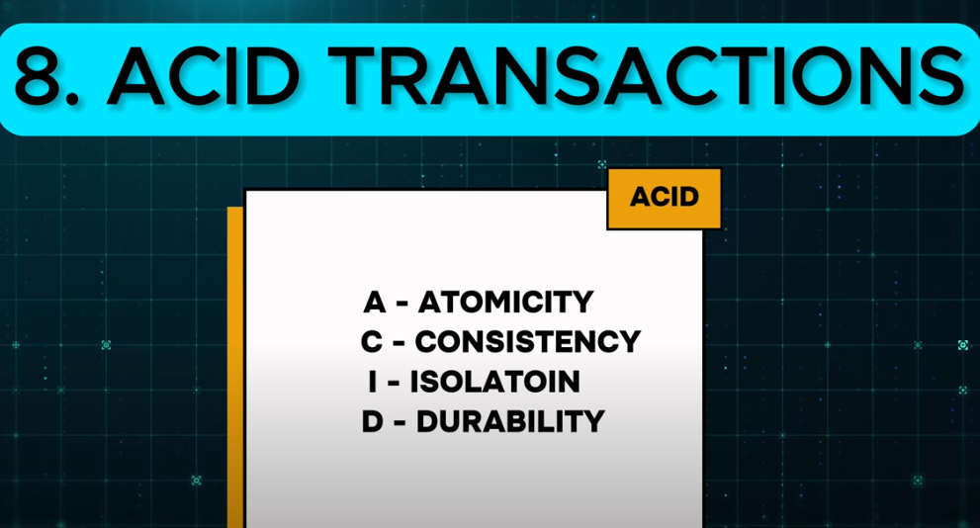

9. Consistence HASHING

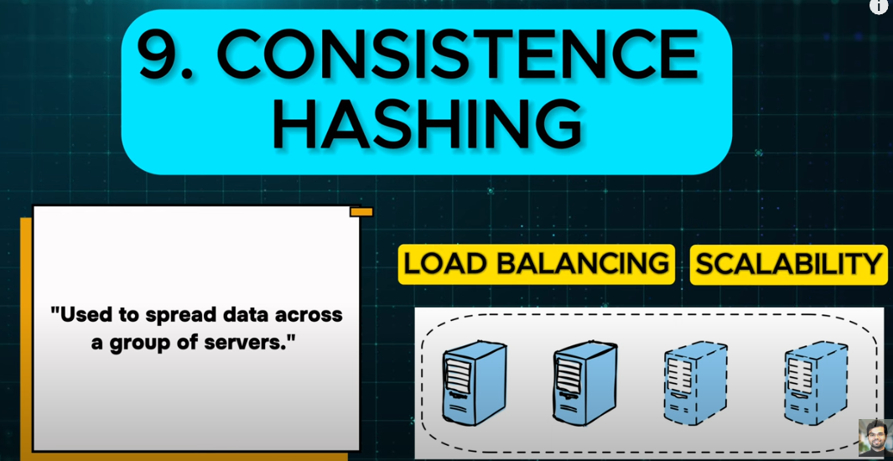

10.Rate Limiting

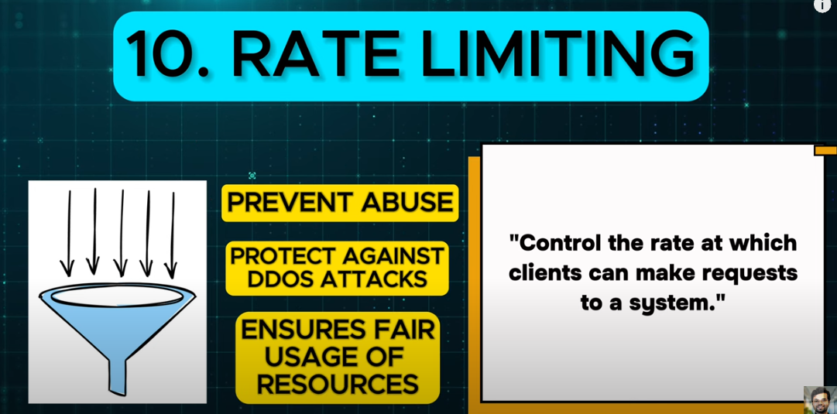

11. Networking & Communications

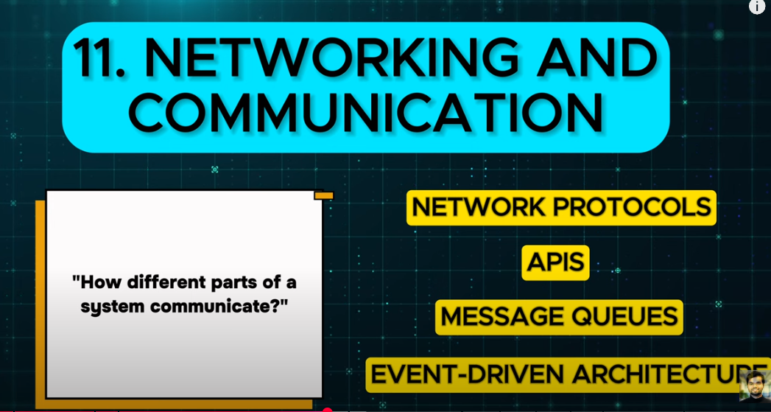

12. Security and Privacy

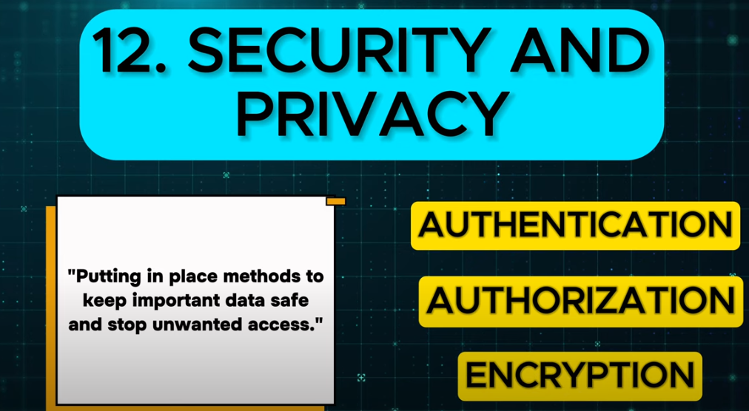

**Building Blocks**

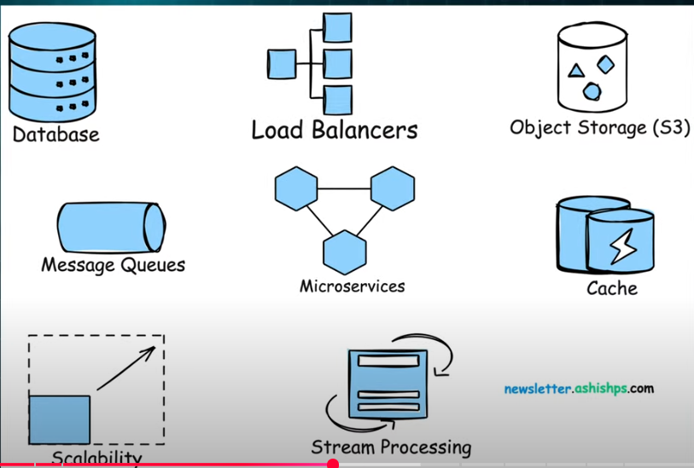

1. **Application SERVERS**

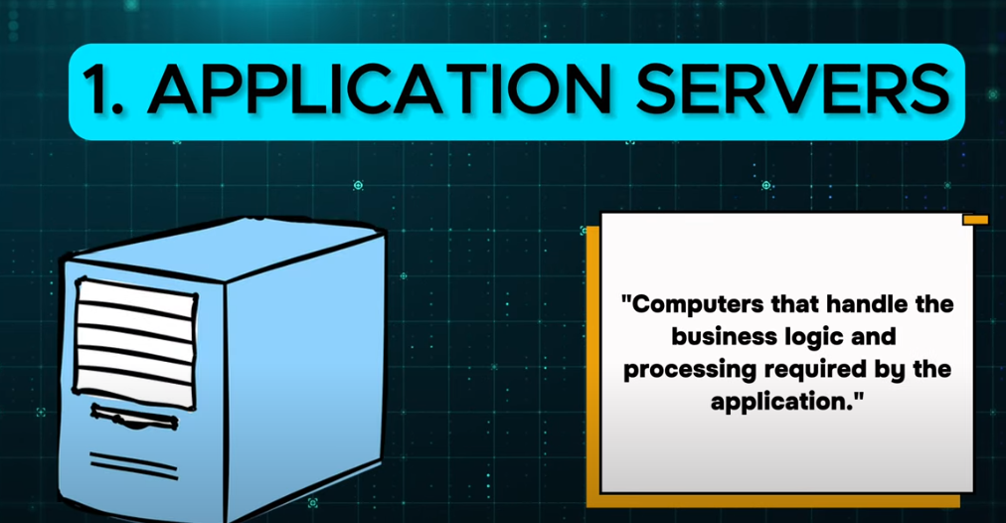

**2.LOAD Balancers**

